Stakeholder mapping contact levels
This is a resource which accompanies our stakeholder mapping guidance. It explains the different contact levels in the stakeholder mapping matrix. You may wish to use this resource when deciding how much to contact stakeholders within your engagement plan, or when considering which stakeholders fit into each category when you are reviewing stakeholders’ positioning after scoring them. If you would like further information, please email engagement.hub@ons.gov.uk.
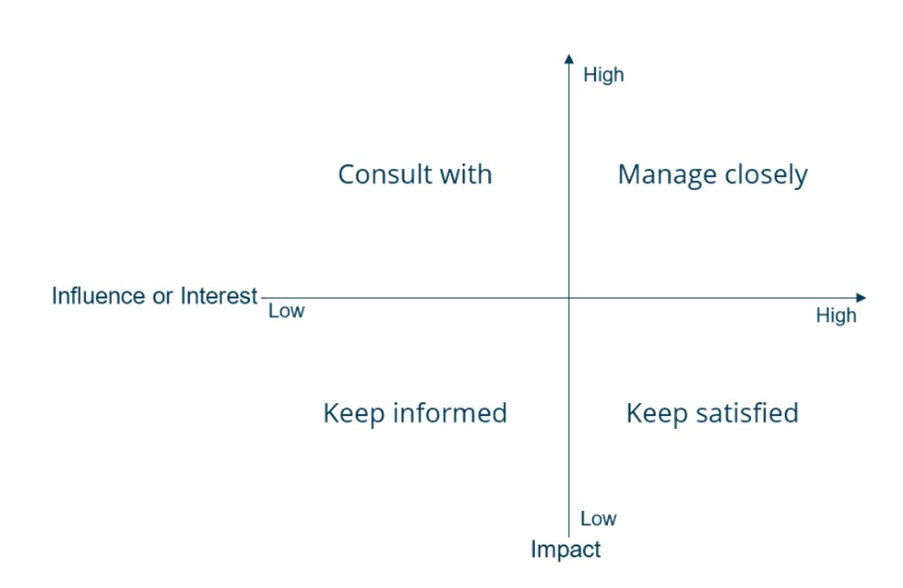
The stakeholder mapping matrix, with contact levels in each quadrant.

Manage closely
This is the highest level of engagement. Stakeholders in this quadrant have valuable insights, advice, or opinions and should be treated as trusted advisors and partners. You should contact them regularly before making changes and throughout the process of the project.
Examples of stakeholders you should manage closely could include:
- government departments or internal teams who are partners in the project.
- stakeholders with whom you share a campaign.
- stakeholders who have the same governance as you.

Consult with
Stakeholders in this quadrant may have less influence or interest but high potential to change the way the project is completed or received if they decide to intervene.
You should update stakeholders in this category at planned points and offer them a chance to provide feedback before making substantial changes. They should be aware of the project and are likely to be supportive of the project. They are unlikely to be as interested in frequent messaging.
Examples of stakeholders you should consult with could include:
- user groups.
- advisory groups.
- open forums.
- attendees of roundtables or conferences which discuss the project topic.
- members of your organisation’s board.
- organisers of public events about your statistical outputs.

Keep satisfied
Stakeholders in this quadrant have a high level of interest or influence in the project, but low impact. You should update them about progress on milestones in the project and consider resolving strong feelings expressed about changes or plans. You may also contact them to test out ideas or to gather support for the project.
Stakeholders you should keep satisfied may be active in similar workstreams.
For example:
- colleagues with regular meetings or task and action groups about your topic.
- government departments who work with similar topics and audiences
- connections who are interested in but not directly affected by the project.

Keep informed
Stakeholders in this quadrant need the least engagement. Update them on milestones in the project and on the timescales for project completion. You can decide other contact purposes based on the overall map and project priorities.
Stakeholders you should keep informed include people and organisations that engage with topics related to the project, but not the same topic.
For example:
- other government departments
- interested citizens
- individual consultants
- academics
These stakeholders may engage with related topics through newsletters, outputs and attending events. They will have minimal involvement in the project itself, but may appreciate updates where capacity allows.

