Module 8: Line Charts

Crossword puzzle – Answers
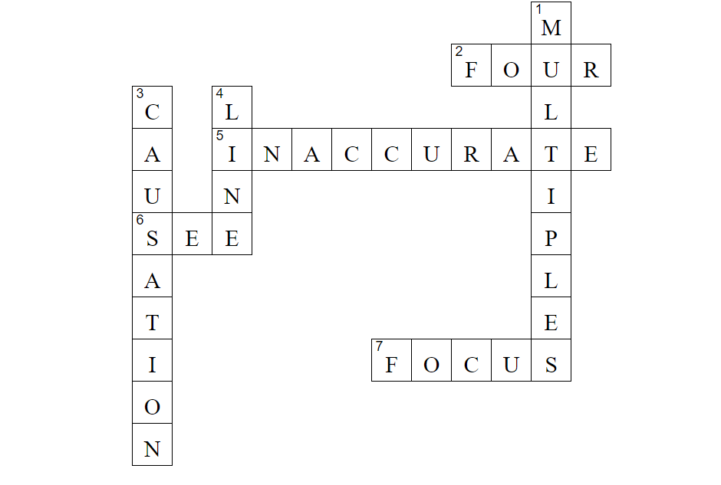

Across
2. We advise a maximum of how many lines on a line chart?
Four
5. Using 3D line charts can cause the values to look what?
Inaccurate
6. It is important that lines are not too thin on a graph as they become difficult to what?
See
7. These line charts are useful to see how one line compares to the other categories
Focus

Down
- A line chart can be separated into small what?
Multiples
3. Correlation does not always mean what?
Causation
4. These charts are best used for time series data
Line

