Module 8: Line Charts

Crossword puzzle

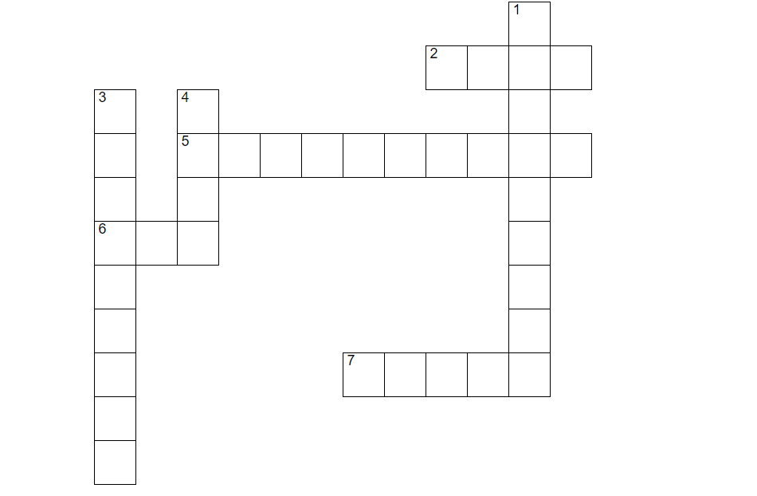

Across
2. We advise a maximum of how many lines on a line chart?
5. Using 3D line charts can cause the values to look what?
6. It is important that lines are not too thin on a graph as they become difficult to what?
7. These line charts are useful to see how one line compares to the other categories

Down
1. A line chart can be separated into small what?
3. Correlation does not always mean what?
4. These charts are best used for time series data

