GOVERNMENT STATISTICAL SERVICE CONFERENCE 2022,
The Midland, Manchester,
13th and 14th December 2022

“Changing statistics for a changing world”

Official Event Partner:

Table of Content
Title | Page number
Chair’s Foreword | 3
Venue and Floor Plan | 4 - 5
General Event Information | 6 - 7
Agenda | 8 - 9
Sponsors | 10 - 11
Keynote speakers | 12 – 14
Parallel sessions | 15 – 28
Conference Committee | 29

Chair’s Foreword
Welcome

As the co-chairs of this year’s Organising Committee, we are honoured to welcome you to the vibrant city of Manchester to join us at the GSS conference 2022, the first in-person GSS conference in three years!

Themed “Changing Statistics for a Changing World”, the GSS conference 2022 aims to reflect on recent GSS work of finding new ways of gathering and processing data, upgrading analysis and better dissemination, including innovations to meet the challenges arise from the coronavirus pandemic and EU-exit.

We have an exciting programme this year, including fantastic speakers such as Sir Robert Chote, Sir Ian Diamond, Ed Humpherson, Dr Emma Gordon, and Robert Cuffe, as well as a diverse range of interesting parallel sessions, exhibitor stalls and posters.

The conference provides an excellent opportunity to meet with colleagues, gain new insights, share experiences, and create new connections. We would like to encourage colleagues to take up the offer to learn from the wide-ranging talks from our GSS colleagues, sponsors and external professionals, get inspired and take back what you learn from the conference to your departments to continue your great GSS work in GSS. And we hope you all enjoy the conference!

Mingqing and Narayan, Conference Committee Co-Chairs

Venue Details:
Venue: The Midland, 16 Peter Street, Manchester. M60 2DS.
The nearest train stations to the hotel are Manchester Oxford Road (200 metres) and Manchester Piccadilly (¾ mile). For train times and journey planning please visit nationalrail.co.uk. The main station for nationwide services is Manchester Piccadilly, which is linked to the hotel by the Metrolink Network (on the Eccles, Altrincham, Manchester Airport and East Didsbury lines, alighting at St Peter's Square) and by the Metroshuttle Free Bus Route.
The conference organisers have scheduled coaches from the location to the venue due to the schedule train strike:

• London
• Edinburgh (potentially via Glasgow)
• Cardiff (via Newport)
• Bristol
• Newcastle (via York and Leeds)

These coaches will leave mid-afternoon on Monday 12th December and arrive in Manchester for the early evening. Return coaches will return delegates and speakers to these cities at around the same time on Wednesday 14th December after the conference. The coaches will be provided free of charge. If you need any further information, please contact a member of the organising team.
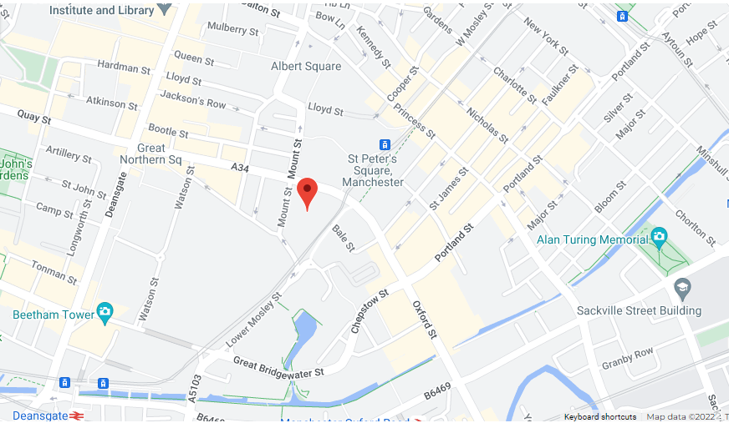

The Midland’s Floor Plan
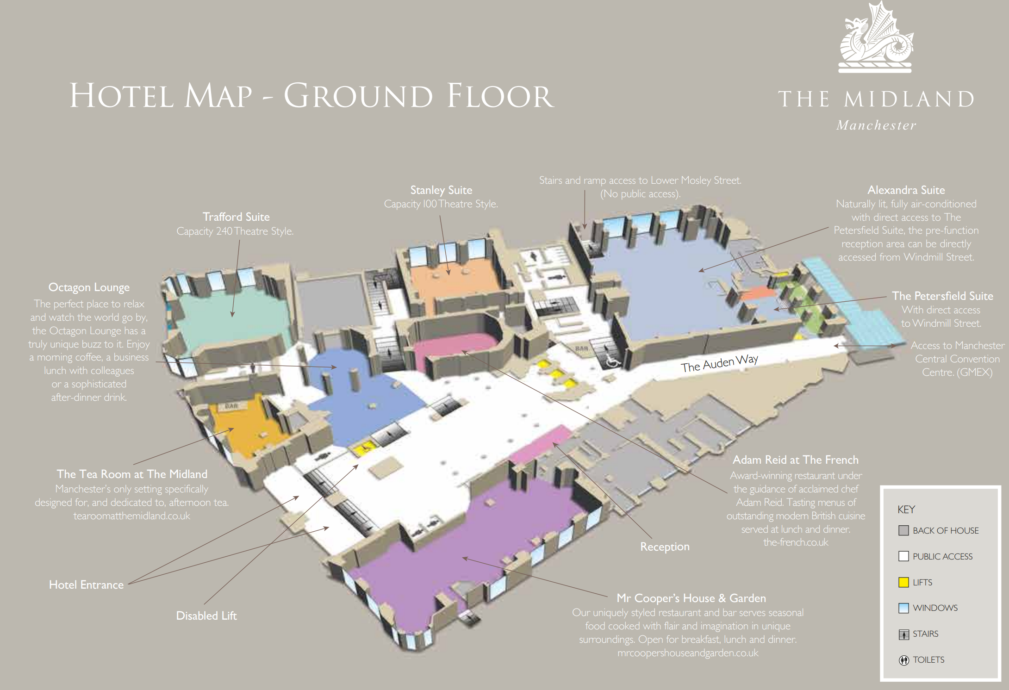
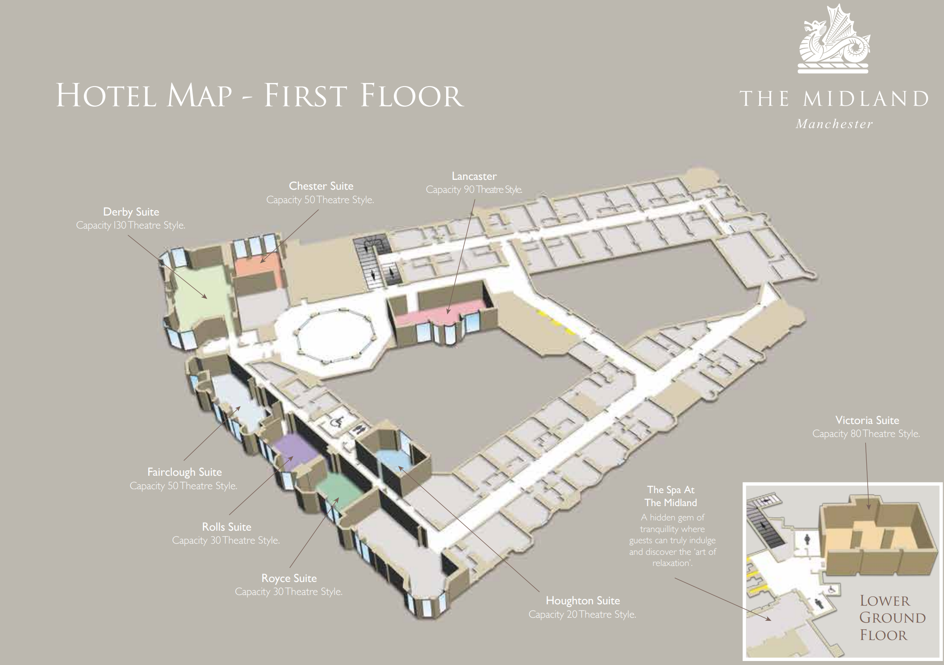

General Event Information

Badges:
Conference attendees are asked to wear their badges and lanyards at all times while in the conference.

Dietary Requirements:
For those attendees who have notified the organisers of dietary requirements, the conference organisers have made arrangements for the lunch and evening meals. If there are any extra requirements needed, please contact a member of the Conference Committee.

Getting Help:
If you need help with anything during the conference, just grab a member of the Conference Committee – We’re wearing matching white T-shirts so should be easy to find!

Luggage:
A cloak Room is available at the ground floor. If you need access, please talk to a member of staff or a Conference Committee member.

Mobile Phones:
We ask that you switch your mobile phones and other handheld devices to silent when you are in the sessions. If you need to respond to emails or make any calls, please use the registration area.

Session Locations:
Keynote sessions will be held in the Alexandra Suite which is on the ground floor. All the parallel sessions will be held across the Alexandra suite, Derby suite, Fairclough suite and Rolls suite. Stalls for exhibitors and sponsors can be found in the Trafford Suite on the ground floor. Please see the agenda (page 8) and the parallel session section (page 15) for additional room information.

Lifts are located at the Ground floor near the reception for access.

Accessibility:
If you have a disability or any additional needs and require assistance, please contact a member of the organising committee.

Audio induction loops are also available at the conference, please contact a member of the organising committee for more information.

Wi-Fi access:

The Midland Hotel have provided free Wi-Fi for all delegates.

The Wi-Fi network is “Midland Guest WIFI” and it doesn’t require a password.

Toilets:
The toilets are located both at the ground floor and first floor. Disabled toilets (located at first floor) can also be used as universal toilets.

Quiet rooms:
The Chester Suite on the first floor is available as a quiet room. If access needed, please contact a member of the organising committee

Meeting rooms:
The Royce Room is available for the meetings. For further information, please contact a member of the organising committee.

Panel session Slido:
Participants can send questions for the panel session Q&A, and provide their answer to the panel question, at slido.com with #1883414 or using QR code:

Agenda
DAY 1: 13th December 2022
Time | Room allocations | Sessions
9:30 – 10:30 | Alexandra Suite | Arrival with tea/coffee and registration (luggage storage, refreshments, and exhibition stalls)
10:30 – 10:45 | Alexandra Suite | Welcome and Open Remarks: Sir Robert Chote (UK Statistics Authority)
10:45 – 11:15 | Alexandra Suite | National Statistician: Sir Ian Diamond (Office for National Statistics)
11:20 – 11:45 | Trafford Suite | Break
11:45 – 12:30 | Alexandra Suite | Keynote Speaker: Emma Gordon (ADR UK)
Parallel Session 1
12:30 – 13:15 | See notice boards | Your choice of session, including The Sensible Code Company (Official Event Partner)
13:15 – 14:15 | Trafford Suite | Lunch
Parallel Session 2
14:15 – 15:00 | See notice boards | Your choice of session, including SAS Software Limited (Gold Sponsor)
15:00 – 15:15 |  | Break
Parallel Session 3
15:15 – 16:00 | See notice boards | Your choice of session
16:15 – 18:30 |  | Please feel free to return to your accommodation before the evening meal
18:30 - late | Alexandra Suite | Evening meal and drinks

DAY 2: 14th December 2022
9:00 – 9:30 |  | Arrival with tea/coffee
9:30 – 10:35 | Alexandra Suite | Keynote Speakers: Ed Humpherson (Office for Statistics Regulation) & Robert Cuffe (BBC)
10:35 - 11:00 |  | Break
Parallel Session 4
11:00- 12:00 | See notice boards | Your choice of session, including Jumping Rivers (Gold Sponsor)
12:00- 13:00 | Trafford Suite | Lunch
Parallel Session 5
13:00 – 14:00 | See notice boards | Your choice of session
14:00 – 15:00 | Alexandra Suite | Panel discussion (including Q&A):  "What is the most important change fuelling transformation in statistics creation and delivery, and how can the GSS respond”  - Douglas Cameron, OFCOM (Head of Statistics)  - Emma Rourke, ONS (Interim Deputy National Statistician) (Director of Health Analysis and Pandemic Insight)  - Mary Gregory, ONS (Deputy Director, Data Science Campus)  - Steve Ellerd-Elliot, DWP (HoP) (Dep. Director, Data as Statistics)  Participants can can engage by going to slido.com  and entering code #1883414, or by scanning the QR code on page 7. You can navigate between the ‘Q&A’ and ‘poll’ tab at the top of the screen.
15:00– 15:15 | Alexandra Suite | Close: Ed Humpherson

Official Event Partner for the GSS Conference 2022
The Sensible Code Company makes products that modernise the processing and dissemination of data. Our product Cantabular facilitates flexible dissemination with real time privacy protection and integrated metadata, improving reproducibility, eliminating errors, and enabling innovative publication tools. It is being used by the ONS to publish census 2021 data.

Come to our exhibition booth and enter our daily draw to win a Turing Tumble

Gold Sponsors for the GSS Conference 2022

SAS is the global leader in AI and analytics, delivering intelligent, automated solutions that help UK government effectively transform data into intelligence. Our technology is designed to empower and inspire how SAS government departments operate, improving the processes and quality of data-driven decision-making. Working collaboratively with other technologies, SAS cloud-resident analytics and AI platform supports diversity, enables scale and promotes trust in government.

Jumping Rivers is an analytics company specialising in creating bespoke solutions for modern business problems. Our team of data science and engineering experts come from many different backgrounds, and their wealth of knowledge and experience allows them to think outside the box and solve problems in new and innovative ways.

Keynote speakers

Sir Robert Chote (Chair of the UK Statistics Authority)
Sir Robert Chote has been Chair of the UK Statistics Authority since June 2022 and is serving part-time as the first chair of the Northern Ireland Fiscal Council and chairs the external advisory group of the Parliamentary Budget Office in the Republic of Ireland. Before this Robert was head of the Office for Budget Responsibility and the Institute for Fiscal Studies and was Economics Editor of the Financial Times and the Independent. Robert was knighted in the 2021 New Year Honours list for services to fiscal policy and the economy.
Key Interest: statistics for the public good.
Sir Robert will be delivering the conference opening speech of the conference.

Robert Cuffe (Head of Statistics, BBC)
Robert Cuffe heads up the statistics team for BBC news. Before that he worked on HIV drug trials at GlaxoSmithKline and was head of statistics at ViiV Health Care. Robert Cuffe is a statistical ambassador for the Royal Statistical Society and was chairman of the UK pharmaceutical statistician’s industry body PSI where he worked with the Science Media Centre to set up a briefing service for the Lay Science Press.

Key Interest: health statistics and improving the communication of statistics.
Robert will deliver the final keynote speech.

Professor Sir Ian Diamond (National Statistician, Office for National Statistics)
Professor Sir Ian Diamond is the National Statistician and Head of National Statistics Board. Ian was the chair of the Social Security Advisory Committee (SSAC) from August 2018 to August 2019, was knighted in 2013 for his services to social science and higher education and was the Principal and Vice Chancellor of the University of Aberdeen until 31 July 2018.

Key Interest: statistical integrity - catch Ian's take on the data revolution on the ONS 'Statistically Speaking' podcast.
Sir Ian will deliver the first keynote speech.

Ed Humpherson (Head of Office for Statistics Regulation)
Ed Humpherson was appointed as Director General for Regulation in October 2013 and took up post in January 2014. He is head of the Office for Statistics Regulation (OSR) which provides independent regulation of all official statistics in the UK. The aim of OSR is to enhance public confidence in the trustworthiness, quality and value of statistics produced by government.
Prior to joining the Authority, Ed was a Board Member and Executive Leader for Economic Affairs at the National Audit Office (NAO), a post he held since July 2009. This role included responsibility for the overall strategic direction of NAO’s work on economic affairs.
Key Interest: Statistics governance (such as preventing the misuse of statistics), regulation and state interaction with the market sector.
Ed will deliver the third keynote speech 'Walls come tumbling down': how the pandemic era has led to the erosion of boundaries for statistics and how this creates new challenges.

Dr Emma Gordon (Economic and Social Research Council and Administrative Data Research UK)
Dr Emma Gordon is Director of the ADR UK Strategic Hub and Director of ADR England. She is responsible for setting the strategic direction for the programme, leading on the coordination of the partnership and engaging with senior stakeholders to improve access and analysis of administrative data to inform policy decisions. She is also part of the ADR UK Leadership Committee. Emma joined ADR UK from HM Treasury, where she led the team supporting government economists and social researchers across government. Prior to this, Emma was Head of Health Analysis at the Office for National Statistics (ONS), and at the start of her career was a post-doctoral researcher on the Avon Longitudinal Study of Parents and Children.
Key Interest: improving access to admin data and supporting better evidence for policy.
Dr Gordon will deliver a keynote speech covering the specific work of ADR UK as well as the wider work of ESRC and its role in data and statistics.

Parallel Sessions Timetable

DAY 1 – 13th December 2022
Parallel Session 1
1.1 | Official estimates of the prevalence of self-reported long  COVID in the UK
Alexandra Suite
 | Sasha King & Dan Ayoubkhani (Office for National Statistics)
In mid-2020, reports began to circulate of debilitating symptoms persisting for months after SARS-CoV-2 infection, known as long COVID. With the initial focus of surveillance in the UK being centred on acute outcomes of COVID-19, there was a lack of robust, population-level data on chronic illness with which to inform health policy, spending decisions and clinical practice. To respond to this emerging public health threat, the Office for National Statistics (ONS) rapidly developed survey questions on long COVID to be added to the Coronavirus Infection Survey
(CIS), a world-leading study of over half a million people randomly selected from the UK population.

Monthly estimates of long COVID prevalence have been published since April 2021, and have revealed the potential burden of disease that would otherwise have remained hidden: 2.3 million
people in the UK (3.5% of the community population) were experiencing long COVID symptoms at the start of September 2022, with nearly half of these first infected over a year previously and over two-thirds reporting an adverse impact on their daily lives.

As well as reporting monthly prevalence, we have collaborated with multiple universities to conduct epidemiological analyses relating to long COVID, particularly on the differing risk profiles by COVID-19 vaccination status and variant of infection, leading to several publications in high-impact journals.

This presentation will outline the ONS’s approach to collecting data on long COVID, the findings of our surveillance and analytical studies, the methodological challenges we have faced along the way, and how we have overcome these challenges.
1.2 | Implementing a Flexible Dissemination System for the 2021 England and Wales Census
Derby Suite
 | Mike Thompson & Aine McGuire - The Sensible Code Company (Official Event Partner)
National Statistical Institutes and other organisations that manage access to confidential datasets are under continually increasing pressure to provide access to more data, more quickly, to researchers and the general public. National Statistical Institutes and other organisations that manage access to confidential datasets are under continually increasing pressure to provide access to more data, more quickly, to researchers and the general public.

Flexible dissemination—the capability to create custom statistical outputs on demand for a user—has the potential to help statistical agencies to meet this demand, and dramatically increase the efficiency of the publication pipeline along with the public value derived from statistical datasets.

We present a case study of the implementation of a flexible dissemination service for the Office for National Statistics in the UK for use with the England and Wales census.

We cover some background to the project, the methodological and technical approach taken to statistical disclosure control, the architecture of the technical solution, some implementation challenges encountered along the way, and look forward to the potential future and further applications.
1.3 | Learning from the pandemic – developing the COVID  dashboard for Scotland, and building on this approach for the release of other official statistics in Scotland
Fairclough Suite
 | Graham McGowan (Public Health Scotland)
The COVID pandemic has left a lasting impact on the production of official statistics in Scotland. Hear about the development of Public Health Scotland’s COVID-19 dashboard from it’s humble origins at the start of the pandemic to the full-blown dashboard, with interactive maps and local geographies, now in use by tens of thousands of users each day.

We’ll also talk through the importance of the release of open data to accompany the dashboard each day so that other users can make their own use of the data, including a direct feed to the UK COVID dashboard and impact this has had. We’ll also touch on how we incorporate user feedback and adapt the contact to suit the stage of the pandemic, ensuring the most relevant data is available to help the public understand what’s happening in their local area and empowering them to make better health and wellbeing
decisions. Automation has also played a key role in producing a huge volume of data every day.

Importantly, as an organisation, Public Health Scotland has learnt a lot from the pandemic and is now embarking on a programme of work to modernise its official statistics estate, making more use of automation, interactive dashboards and open data. This talk will
outline our plans and how the legacy of the pandemic will continue for many years.

1.4 | Harnessing the potential of linked administrative data for the justice system
Rolls Suite
 | Georgina Eaton & James Doherty (Ministry of Justice)
Data First is a data-linking programme led by the Ministry of Justice (MoJ) and funded by ADR UK (Administrative Data Research UK). The programme links administrative datasets from across the justice system and with other government departments to provide powerful new insights on justice system users, their pathways, and outcomes across a range of public services.

The session will provide an overview of the Data First programme, the achievements to date and the research potential of the Data First datasets. We will demonstrate how linked administrative data available through the ground-breaking Data First programme can be effectively used for research, how we have built relationships with partners and how the programme is providing a rich resource to develop the evidence base for government policy and practice in a changing world. We will share lessons learnt from the programme so far to encourage and promote the potential and benefits of the routine sharing of administrative data across government departments and for academic research.

Additionally, we will present key findings from our ONS award winning descriptive analyses on repeat users of the criminal courts in England and Wales using our linked criminal courts data and findings from a MoJ and Department for Education publication on the education and social care background of children who had been cautioned or sentenced for an offence.

Overall, the session will demonstrate how linked administrative data available through the Data First programme can be effectively used for research for policy impact in our changing world.
Parallel Session 2
2.1 | International Standards for Official Statistics on Climate-Health Interactions​
Alexandra Suite
 | Megan Green & Jamie Cranston (Office for National Statistics)
The single greatest threat to human health is Climate Change. With temperatures rising, air quality declining, outbreaks of disease increasing and natural disasters becoming more frequent, the effect of climate change on human health is a serious and growing concern. The impact of this is felt disproportionately by the most vulnerable and disadvantaged groups, who currently suffer the highest mortalities and other health effects from climate related risk

So, how can we help to increase action taken to reduce the impact of climate change? There is currently a lack of harmonised approaches and statistical methodology available that allows countries to consistently and easily produce official statistics to evidence the impact of climate change on health, especially in low/middle income countries where there may be less resource. Without reliable statistical evidence, it is hard to communicate issues and implement new policies for national and global climate change action.

Wellcome, a global charitable foundation, is funding the Office for National Statistics (ONS) UK to develop Standards for Official Statistics on Climate-Health Interactions. This will enable countries to develop reporting on climate change through consistent and high-quality metrics at a national and local level.

In October, we are visiting Africa to find suitable countries to partner with, these visits are a unique opportunity to understand the setup of their National Statistics office and government organisations. The partnership will allow a joint collaboration on our project as well as building statistical capacity in the partnership countries.

2.2 | The importance of transparent and ethical decisions from predictive models
Derby Suite
 | Harry Snart - SAS Software Limited (Gold Sponsor)
Whilst GDPR set a precedent around citizen protection within the context of automated decision making, the majority of predictive models leveraged in government are not fully automated. Often, predictive models are used as a means of augmenting and accelerating analyst workload. As such, there is currently very little regulation around the quality of models or any potential biases that may exist.

Launched in 2021, the National AI Strategy has brought a renewed focus on the importance of better understanding, governing and utilizing predictive models which directly or indirectly influence the daily lives of citizens. This ten-year plan seeks to not only encourage investment and adoption of AI in practice, but also bring in new guidance and standards for AI best practice within the Public Sector.

In this session, we will introduce some of the concepts and risks of AI bias and demonstrate how SAS Viya can be used to enable polyglot data science teams to monitor their data science projects for unconscious bias and how data stewards can flag sensitive or incomplete datasets within an enterprise data governance framework, helping data scientists find and work with the data they need faster.
2.3 | Statistics improvement at the Gambling Commission
Fairclough Suite
Helen Bryce & Ben Haden (Research & Statistics, Gambling
Commission)
The Gambling Commission is responsible for regulating gambling in Great Britain. It is an evidence-based regulator providing information to Government on the extent and impact of gambling in Great Britain. In this presentation the Gambling Commission will share its experiences as it undergoes a statistics improvement programme.
The Commission undertakes a programme of research focused on understanding why and how people gamble, how this differs across different segments of the population, how behaviour changes over time and who is at risk from experiencing harm from their gambling.

From an industry perspective it also needs to understand the gambling opportunities available and how the market is evolving over time. To do this, they gather evidence from a range of data sources and the Research and Statistics team have been on a
mission to improve the range and quality of the evidence it gathers.
During the presentation, the team will give a number of examples of statistics improvement projects they are undertaking including;
changing the way it collects data on adult gambling participation and problem gambling statistics, by piloting a new push to web methodology developing an approach for measuring those experiencing gambling related harms improving our young people research. They will also discuss ambitions for the future including undertaking longitudinal research and exploring opportunities for data linkage.
2.4 | Turn data into information with this one simple trick
Rolls Suite
 | Andrew Fergusson (Office for National Statistics)
Information should be for everybody, and everybot.
The problem with spreadsheets is that knowledge is either inferred or assumed (or just randomly mashed together – looking at you, data scientists). ONS’ Integrated Data Service Dissemination
workstream is (re)publishing datasets as CSV on the Web. CSV-W is a csv with additional files of metadata describing its contents and schema. CSV-Ws enable explicit definitions of shared resources like geographies, time periods, and other common identifiers like SITC so that both humans and bots can understand the data within its context to create knowledge (hint: it’s the links).

We will introduce csvcubed, our CSV-W generating python package. Then we show you how to turn your data into information. Next, we’ll show how this package can be integrated with secure or public generation pipelines (include a free GitHub Action with no local install required!). Finally, we show the benefits of annotated data for both analysis and visualisation. This revolutionises the way statistics are published and consumed, making fully annotated data
portable for the analyst and interested public. Observation value footnotes become a thing of the past, and concepts are linked and
their comparability is established making reconciliation for end users a thing of the past.

Topics covered (some very briefly), but no prior knowledge is required: python, JSON, linked data, CICD pipelines, data representation, RDF, SPARQL, and visualisations.
Parallel Session 3
3.1 | Fuel poverty statistics in a volatile energy market
Alexandra Suite
 | Stephen Oxley & Aaron McMahon (Department for Business, Energy, and Industrial Strategy)
Hot on the heels of monitoring the ability of households to manage energy costs through the economic and social changes faced by households through the pandemic, statisticians have responded to a wider range of analytical and policy challenges to deliver timely, relevant and meaningful statistics in an orderly manner to support a national debate central to cost of living, wellbeing and economic stability.

This session will cover how statisticians have led the debate on fuel poverty and delivered statistical outputs in an uncertain policy and economic landscape. Undertake a range of work to listen to and influence stakeholders to form a balanced understanding of the “crisis”, supported analysts and policy making cross-Whitehall to develop schemes capable of supporting households with energy bills and driving more relevant and timely statistics.

The session will cover how the team carried implemented a new package of policy measures into the statistics, took steps to improve the relevance through advancing the timetable, managed the challenge of stakeholders using other measures and sensitivity analysis in response to price uncertainty.
3.2 | Irregular migration: Small boats crossing the English Channel
Derby Suite
 | Francesca Allerton (Home Office)
In recent years, irregular migration to the UK – the movement of people into the country without permission to do so – has changed dramatically. The number of people making the dangerous journey across the English Channel in small boats has surged, from 300 people in 2018 to over 28,500 in 2021. High volumes of arrivals have continued in 2022, but the New Plan for Immigration and the Migration Economic Development Partnership with Rwanda may lead to rapid changes in the situation.

As the world of irregular migration changes, our statistics have had to change too. Collaboration between Home Office, UKSA and MOD has enabled us to move from the ad-hoc reporting of figures to the media, to publishing regular and accessible Official Statistics which provide a trustworthy and coherent source of the truth.

In this session, we will explain how factors such as the COVID-19 pandemic and organised crime have had an impact on small boat crossings and other irregular migration routes, which have in turn had knock-on impacts on the wider immigration system (such as increasing the backlog of asylum claims). We will outline the challenges and lessons learnt from launching a new statistics release – balancing between the need for high quality regulated releases with wider political and public pressures for timely data.
3.3 | The thirst for timely statistics - changing the way DLUHC delivers
Fairclough Suite
 | Sally Frost & Aislinn McDonagh (Department of Levelling Up, Housing and Communities)
DLUHC publishes quarterly and annual official/national statistics releases to support its policy responsibilities. Whilst we’ve made improvements, shortening time between collection and publication, we had retained this frequency.

This changed overnight in 2017 after the Grenfell Tower fire. In week one we used macro data to establish other buildings at risk and commenced collecting data on c.6,000 buildings, reporting to COBR thrice daily. In the five years since, we publish management information monthly on high-rise building safety, utilising innovative data science techniques to lead on holding and linking data on 87,000 11m+ residential buildings in England.

This set the precedent for sharing timely management information in other areas. We monitored numbers of vulnerable people helped off streets into accommodation as part of Government’s ‘Everyone In’ campaign during Covid; measured demand for sponsors from ‘Homes for Ukraine’ scheme by matching Home Office visa data with offers of sponsorship, providing geographical breakdowns to highlight potential local pressure; and as leaseholders struggled to move, gathered mortgage lenders data to support evidence-based policy decisions around interventions in the flat mortgage market.

The publication of these datasets are now routine publications allowing our users access to timely information. From daily information collection to online dashboards monitoring and responding to local and national situations, we publish as frequently as needed - driving better outcomes through increased data and transparency. We have done this whilst consistently adopting the Code of Practice, winning OSR’s first Voluntary Application of the Code Award for our Building Safety Data Release.
3.4 | Reporting environmental data in a post-Brexit world
Rolls Suite
 | Susie Wright & Elise Baseley (Department for Food & Rural Affairs)
The need for environmental statistics and data is changing. EU exit has led to changes to the regulatory environment, while pressing environmental challenges, such as climate change and biodiversity loss, demand cross-cutting evidence to understand and solve them.

To ensure future demands are met, Defra has developed a new reporting strategy, with a vision for those involved in reporting environmental data to work together across organisational and national boundaries within a streamlined system that is focused on addressing users’ needs. In the past year, action has been taken to drive progress towards realising this vision, including setting up new mechanisms for collaboration across the UK, taking a systems approach to understanding the hierarchy of environmental data produced by Defra, and exploring new approaches for user engagement. This work is ensuring that our environmental statistics are ready for the changing world by building coherency across the UK where needed in the face of regulatory divergence and improving findability and accessibility of data for users, particularly those with cross-cutting needs.

In this parallel session we will share the findings from this work and how they can be applied to support statistics across government to adapt to a changing world. Our approach to enabling knowledge exchange between statistics producers working on similar problems in different areas will be explored, as will lessons learned on user research and disseminating statistics with user need in mind.

DAY 2 – 14th December 2022
Parallel Session 4
4.1 | Can less be more? How we made our flagship publication 4x shorter and helped journalists quote us 4x more
Alexandra Suite
 | Joseph Adams, Rhiannon Batstone & Andrew Guthrie (National Records of Scotland)
Joe will reveal how his team won an Analysis in Government Award in the communication category. There will be metrics, lessons learnt, and resource recommendations.

Topics may include:
Why statistics communication is so challenging: literacy, reading habits, signal to noise ratios, and the curse of knowledge.

How our team prioritises improvements: user’s hierarchy of needs, Pareto distributions, and adding content vs removing it.

Our surprisingly simple recommendations to make life easier for users and statisticians. Joe’s current team focusses on improving the reach and impact of demographic statistics produced in National Records of Scotland. Joe has worked in various analytical roles with PricewaterhouseCoopers, NHS Scotland, and Scottish Government. If Joe could recommend one work-related book, it would be Top Tasks by Gerry McGovern.
4.2 | So, you've got an app that you want to share…what happens now?
Derby Suite
 | Andrew Patterson - Jumping Rivers (Gold Sponsor)
This talk introduces the key concepts necessary to quickly and reliably deploy and manage data science applications in production. We'll introduce you to:

- Automation for build and test
- Your app from an infrastructure viewpoint
- Appraising options for app deployments
- Infrastructure as code
- Automation for app deployment
- Pointers for managing applications in production
4.3 | A united GSS response to the Ukraine crisis
Fairclough Suite
 | Bex Newell, Jack Cooper, Sandra Tudor & Klara Valentova (Home Office, DLUHC & ONS)
This session will showcase the critical importance data has played as the Ukraine crisis unfolded and how joined up working at pace across the GSS has delivered timely and informative statistics in the public domain.

The chair will provide an overview of the analytical response to the emerging crisis, embedded statisticians at the heart of the Governments response to ensure statistics were integral in the
end-to-end system design for reporting, championing best practise, and publishing harmonised statistics from across the GSS.

Home Office – presentation on the innovative data matching work that was developed at pace to understand and report on Ukraine visa arrivals under the Ukraine Family Scheme and Ukraine Sponsorship Scheme.

DLUHC – presentation on the ‘Homes for Ukraine’ policy with a focus on the local area response (including devolved administrations) and local area geographical data.

ONS – presentation on the UK Humanitarian Response Insight Follow-up Survey which looks to understand the opinions and experiences of those arriving in the UK under both visa schemes, and how these might have changed since they completed the first survey in April 2022.

Parallel Session 5
5.1 | The changing world of homeworking: Who is  homeworking in the UK and how can we measure this?
Alexandra Suite
 | James Probert & Chris Hendry (Office for National Statistics)
One of the enduring effects of the pandemic has been a rise in the popularity of home and hybrid working. This fundamental shift in how we work has had complex impacts on society and the wider economy. Understanding how working patterns have changed and the extent of both positive and negative impacts resulting from these changes is a priority across government departments and key to informing future policy decisions.

The ONS has published several analytical pieces on this theme; in this session we will present our findings on the underlying trends in homeworking and its potential impacts. We will address the questions of:
- What effect has homeworking had on individual finances and what are the key items driving any change?
- How has homeworking varied pre and post pandemic and what differences are there between regions?
- How have inter and intra-regional commuting patterns changed over time?
- Who is more likely to be home or hybrid working across different demographics?
- Other than occupation, what demographic factors mean you are not likely to be able to work from home?

In this session we will also cover the key data sources used for our analyses, their limitations and strengths, as well as the underlying statistical principles behind our methodology.
5.2 | Improving data use in policing to reduce crime
Derby Suite
 | Katie McMillan-Nuttall & Maisie Williams (HM Inspectorate of Constabulary and Fire and Rescue Services)
In 2021, we embarked on a journey to create a one-stop shop to provide crime insights across the breadth of policing, which was data and analytically driven. The overarching aim of this has been to reduce crime levels, one of the Prime Minister’s key priorities as described in the Beating Crime Plan.

Through this initiative, we’ve created an interactive digital tool, called the Digital Crime and Performance Pack (DCPP) on Microsoft Power BI. This helps the policing sector consistently track progress against the National Crime and Policing Measures. We’ve been unlocking the potential of unpublished crime data by sharing it across the policing collaboration. We’ve done this safely through strong governance and shared principles on use of data.

This has given us the opportunity, for the first time, to share granular unpublished crime data between organisations such as police forces, locally elected bodies, Home Office, National Crime Agency and NHS-Digital to improve strategic policing and reduce crime. The DCPP has interactive visualisations of data on homicides, serious violence, neighbourhood crime, drugs and violence against women at police force level and beyond. It also includes contextual indicators of crime through open source data, such as the Ordnance Survey.

We’ve used Agile principles and methods to iteratively develop and deploy the DCPP through user-centred product development. Since releasing the DCPP in December 2021, we’ve onboarded over 700 users across policing, ranging from Chief Constables, PCCs, strategic leads in national policing through to analysts in Home Office and police forces.
5.3 | Mental Health of Children and Young People in England and changes since 2017
Fairclough Suite
 | Mila Savic & Walt Treloar (NHS Digital)
The Mental Health of Children and Young People (MHCYP) survey series provides England’s Official Statistics on trends in child mental health. The most recent face-to-face survey took place in 2017 and involved interviews with a random sample of children and young people (aged 2 to 19 years) and their parents. In summer 2020, to understand the impact of the pandemic on children and young people, we recontacted participants and invited them to take part in an online follow up survey (Wave 1). To monitor trends over time the cohort were also asked to take part in further online surveys in March 2021 (Wave 2) and April 2022 (Wave 3). Prior to each wave we worked with key users to understand requirements, adapting survey questions to meet user needs and changing covid restrictions.

Findings so far from the surveys:-
- Rates of probable mental disorders have increased since 2017; in 6 to 16 year olds from one in nine (11.6%) to one in six (17.4%), and in 17 to 19 year olds from one in ten (10.1%) to one in six (17.4%).
- The proportion of children and young people with possible eating problems increased since 2017 to 2021; from 6.7% to 13.0% in 11 to 16 year olds, and from 44.6% to 58.2% in 17 to 19 year olds.

This session will present the latest findings from Wave 3, due for publication November 2022. The 2022 survey covers mental health, education and employment, contact with services, social
media and eating disorders.
5.4 | Smoking, vaping, drinking alcohol and illicit drug use in young people in England
Rolls Suite
 | Stephanie Gebert (NHS Digital)
In September 2022, we published the latest results from a survey of secondary school pupils in England focusing on smoking, drinking alcohol and illicit drug use. This was the first time the survey had run since the covid pandemic; we’ll present information on latest findings and how these have changed over time.

We have rebuilt this process as a reproducible analytical pipeline recoding all the outputs using open-source software languages including python and R with our code store in a gitlab repository. We’ll present the benefits of an automated publication process and how it made it easier to produce new outputs relating to the pandemic.

Exhibition Stalls

The Sensible Code Company
SAS Software Limited
Jumping Rivers
… and more

Conference Committee members

Co-Chairs
Mingqing Wu, Office for National Statistics
Narayan Jayram, Department for Work and Pensions.

Venue team
Ben Peters, Department for Business, Energy and Industrial Strategy
Cheena Ghataoura, Department for Education
Dan Clarke, Office for National Statistics

Communications team
Zarrin Pudney, Welsh Government
Ian Hillis, Service Complaints Ombudsman for the Armed Forces
Camilla Somers, Public Health Scotland

Delegates
Kitty Dadds, Department for Transport
Tara Smith, Department for Transport

Parallels sessions team
Michael Nairn, Office for National Statistics
Beth Cunningham, Department for Education

Keynote sessions team
Fabiana Macor, Ministry of Justice
Oluwakemi Imole Adewumi, Department for Work and Pensions

Sponsorship team
Jack Bedford, HM Revenue and Customs
Henry Watson, Department for Work and Pensions

Conference blog and twitter feed

You can find our official blog for the GSS Conference at https://analysisfunction.civilservice.gov.uk/events/government-statistical-service-gss-conference-2022/

We have been posting in the run up to the conference and will be posting during and after the conference too!

For tweets about the conference, see the official GSS Twitter account (@UKGSS). If you send any tweets about the conference, please use the hashtag #GSSConf2022

Official Event Partner:

Gold Sponsors:

